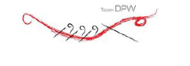
Los Angeles County Dragon Boat Festival
Marina del Rey
March 2, 2024
Captain’s Attestation Form

By signing this, I (name) ____________________________ as captain of (Team Name) __________________________ participating in the 2023 Los Angeles County Dragon Boat Festival- MdR, on March 2, attest to the following:

1) E-waivers are complete and signed by all my team members racing in my boat & listed on the roster in this packet. _________ (Initial)

2) I take full responsibility for checking these aforementioned items, and answered them as true, to the best of my knowledge. ________ (Initial)

________________________________________________ (Captain’s Printed Name) ________________________ (Date Signed)

________________________________________________ (Captain’s Signature)

________________________________________________ (Captain’s Phone Number)

________________________________________________ (Captain’s Email)

